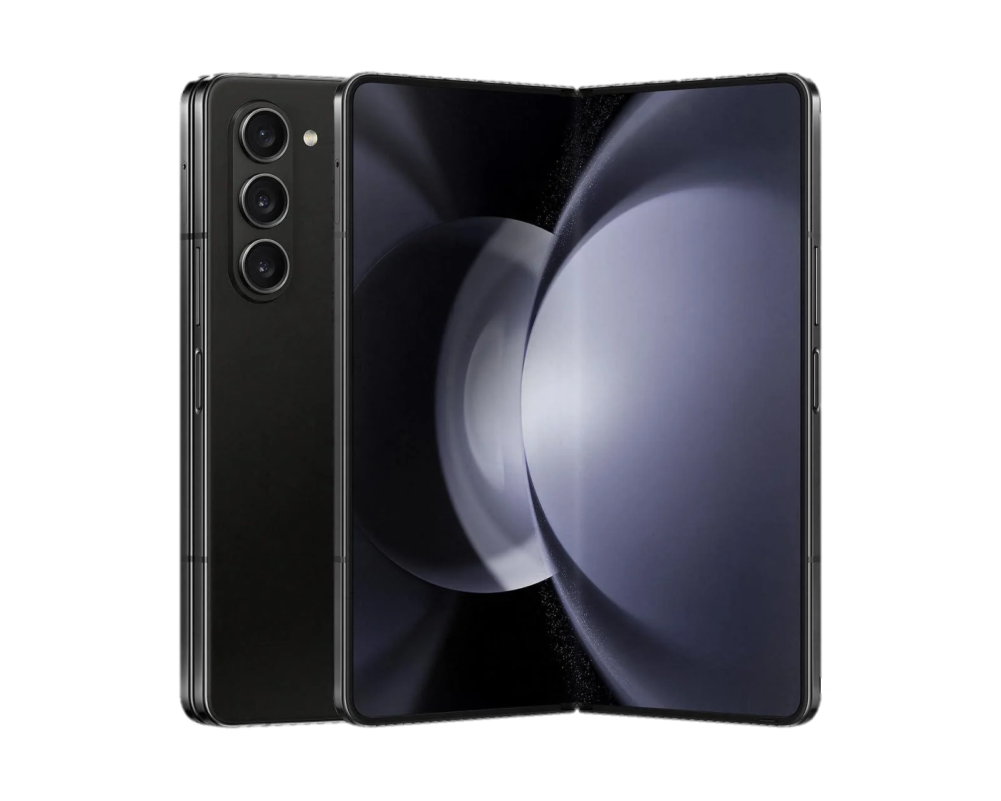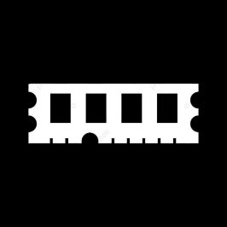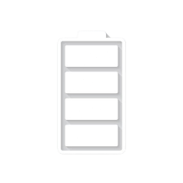

Price: $ 724.50

GALAXY Z FOLD 5

* Processor: Qualcomm SM8550-AC Snapdragon 8 Gen 2 (4 nm)
* Front Camera:4 MP
* Rear Camera:50 MP
* Display:7.6 “
* NFC:Yes:
* Colors: Icy Blue, Phantom Black, Cream, Gray, Blue
* Operating System:

Android 13

* Charging Type:USB Type-C
* SIM: Nano-SIM and eSIM or Dual SIM
* Fingerprint:Yes
* Release Date: 2023, July 26

RAM

12

GB

ROM

01

TB

BATTERY

4400

mAh



+001-28272300-2466-2469



webmaster@cellinfo.com



A-65, ACME Co. ,

Street No. 12,

New York

Ask Me Ltd.